**SVKM’s NMIMS**

**Mukesh Patel School of Technology Management & Engineering**

**Department of Electronics and Telecommunication Engineering**

**Subject: Image and Video Processing Program: B.Tech/BTI/MBA**

**Sem: VII/IX/V ACAY: 2020-21**

**EXPERIMENT NO. 5**

**Aim:**

1. To write a program in PYTHON to plot histogram of an image
2. To plot histogram of different images and classify them as low contrast, high contrast, dark and bright images.
3. To write a program in PYTHON to perform histogram stretching on an image
4. To write a program in PYTHON to perform histogram equalization

**Software:**  PYTHON

**Prerequisite:**

|  |  |
| --- | --- |
| Sr. No | Concepts |
| 1. | Histogram-basics |

**Outcome:**

After successful completion of this experiment students will be able to:

Concept of histogram, histogram stretching and histogram equalization

**Theory:**

It is essential to use the following command at the beginning of each program to clear the command window, close all the figures which are open, and clear all the variables.

>>clc;

>>close all;

>>clear all;

**Histogram**

A histogram is a graph. The x axis contains event (pixel intensity) whose frequency you have to count. The y axis contains frequency.

There are two methods of enhancing contrast namely histogram stretching and histogram equalization.

**Histogram stretching**

Modified pixel value is given by

$s=\frac{s_{max}-s_{\min{}}}{r_{max}-r_{\min{}}}\left(r-r_{\min{}}\right)+s_{min}$

where

s_max= max grey level of the output image

s_min = min grey level of the output image

r_max= max grey level of the input image

r_min = min grey level of the input image

**Histogram equalization**

Steps to perform histogram equalization

* Plot histogram of the original image
* Calculate PDF
* Calculate CDF
* Perform mapping to get the output image
* Plot the histogram of the output image.

|  |
| --- |
| Name of the Experiment: To view histogram, equalize it, and stretch for three images. |
| Roll No. C018 Name: Dhruvit Jain |
| Program: B.Tech ExTC Semester : VII |
| Date of Performance:07/08/2020 Date of Submission: 07/08/2020 |

**Code for histogram viewing:**

from scipy import misc

from skimage import io

import matplotlib.pyplot as plt

img = misc.face()

io.imshow(img)

plt.figure()

plt.figure(figsize=(15,5))

plt.subplot(1,3,1)

img1=img[:,:,0].ravel() #converts into a flattened 1D array

ax = plt.hist(img1, bins=256,color='r')

plt.xlabel ("Intensity-->")

plt.ylabel ("Number of pixels-->")

plt.title ("Histogram for Red Plane")

plt.subplot(1,3,2)

img1=img[:,:,1].ravel() #converts into a flattened 1D array

ax = plt.hist(img1, bins=256,color='g')

plt.xlabel ("Intensity-->")

plt.ylabel ("Number of pixels-->")

plt.title ("Histogram for Green Plane")

plt.subplot(1,3,3)

img1=img[:,:,2].ravel() #converts into a flattened 1D array

ax = plt.hist(img1, bins=256,color='b')

plt.xlabel ("Intensity-->")

plt.ylabel ("Number of pixels-->")

plt.title ("Histogram for Blue Plane")

**Outputs for Histogram:**

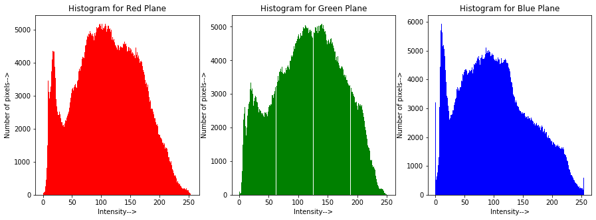

**Code for histogram equalization:**

import numpy as np

image = io.imread ('C:/Users/dhruv/Desktop/College/NOTES/IVP/Labs/pollen_very_dark.tif')

# io.imshow (image)

sh=image.shape

row = sh[0]

col = sh[1]

num_pix = row*col #number of pixels

imhist,bins = np.histogram(image.ravel(),256) #create histogram

cdf = imhist.cumsum() #cumulative sum in an array form

cdf_modified = (cdf*255)/num_pix

s=cdf_modified.astype(int)

im_eq = image.copy()

for r in range (0,row):

for c in range (0,col):

temp= image[r][c]

im_eq[r][c]= s[temp]

plt.figure()

plt.figure(figsize=(7,7))

plt.subplot(2,2,1)

io.imshow (image)

plt.title ("Original Image")

plt.subplot(2,2,2)

io.imshow (im_eq)

plt.title ("Equalized Image")

plt.subplot(2,2,3)

ax=plt.hist(image.ravel(),bins=256)

plt.xlabel ("Intensity-->")

plt.ylabel ("Number of pixels-->")

plt.title ("Histogram for Original Image")

plt.subplot(2,2,4)

ax=plt.hist(im_eq.ravel(),bins=256)

plt.xlabel ("Intensity-->")

plt.ylabel ("Number of pixels-->")

plt.title ("Histogram for Equalized Image")

**Output for very dark image:**

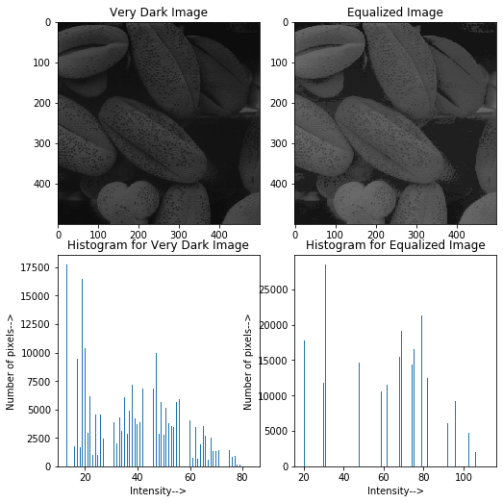

**Output for dark image:**

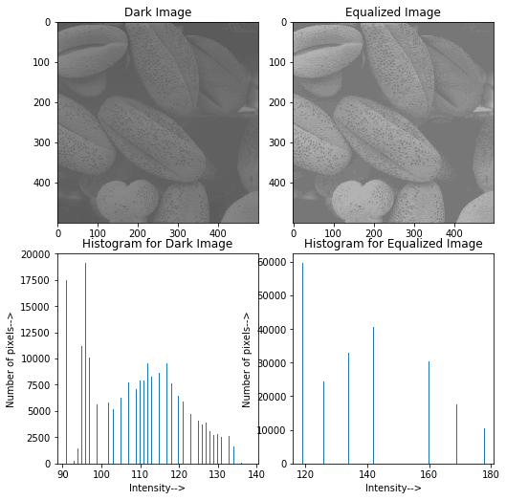

**Output for bright image:**

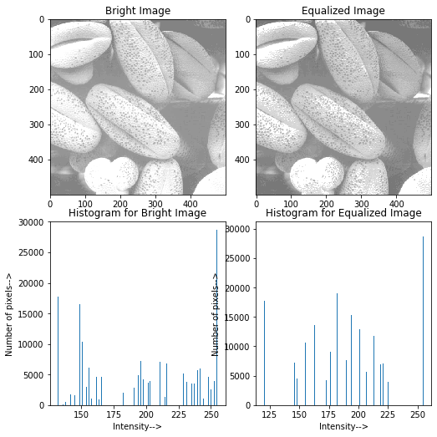

**Code for histogram stretching:**

#Histogram stretching

#stretches minimum and maximum pixel intensity in original image to the range 0 to 255

image = io.imread ('C:/Users/dhruv/Desktop/College/NOTES/IVP/Labs/pollen_very_dark.tif')

sh=image.shape

row = sh[0]

col = sh[1]

s_min = 0

s_max = 255

r_min= np.min(np.min(image))

r_max = np.max(np.max(image))

im_stretch = image.copy()

for r in range (0,row):

for c in range (0,col):

temp1= image[r][c]

temp2 = (((s_max-s_min)/(r_max-r_min))*(temp1-r_min))+ s_min

im_stretch [r][c] = temp2

plt.figure (figsize=(7,7))

plt.subplot (1,2,1)

io.imshow (image)

plt.title("Original Image")

plt.subplot (1,2,2)

io.imshow (im_stretch)

plt.title("Stretched Image")

**Output for very dark image:**

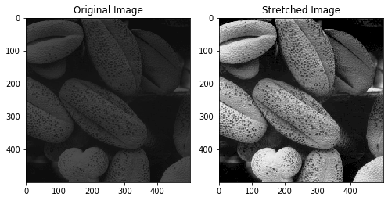

**Output for dark image:**

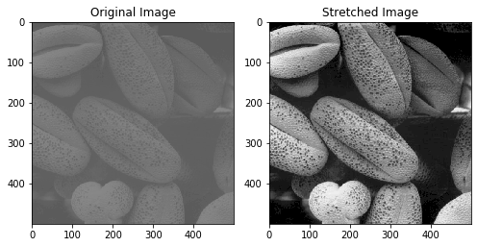

**Output for bright image:**

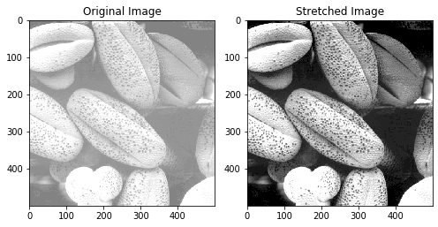

**Conclusion:**

* Histogram of very dark image shows that most of the pixels are in the range 0 to 80.
* Histogram of dark image shows that most of the pixels are in the range 0 to 140.
* Histogram of bright image shows that most of the pixels are in the range 150 to 250.
* After equalizing these images, histogram is redistributed in the range 0 to 255 for all. Therefore, all the equalized images have pixel intensities in the range 0 to 255.
* Histogram stretching reduces minimum pixel intensity of original image to 0 and increases maximum pixel intensity to 255.
* Intermediate pixel intensities of the original image are increased proportionately.
* In histogram equalization, number of pixels with various intensity values are redistributed whereas in histogram stretching, pixel intensities are transformed to new values to cover the entire range. They are not redistributed.